
To relieve the strains on the production system, Reporting Services copied the table and 3 supporting tables into its own staging area.

The focus of this project was to reduce the size of the main report table and to have the 3 reports run more quickly.

Six Sigma helped quantify the extent and the severity of the reporting problem, which was larger than anticipated. The process provided a scientific approach to solving the problem, and the team was able to create and rank several potential solutions to choose the best one possible.

Process Changes implemented:

• Use logic to distribute the main table’s data to one of 4 relevant subject area tables.
• Load only meaningful data and meaningful records.
• For the 3 support tables, load only the columns used within the reporting logic.

Results:

• The main report replacement tables utilized 34.8% of the space used by the original table.
• The replacement support tables utilized 23.7% of the space used by the original ones.
(See Figure 1)
• Run-times for the 3 reports dropped to 3%, 17%, and 24% of the original run-times.
(See Figure 2)

Figure 1
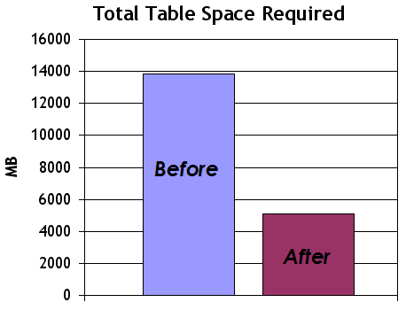

Figure 2
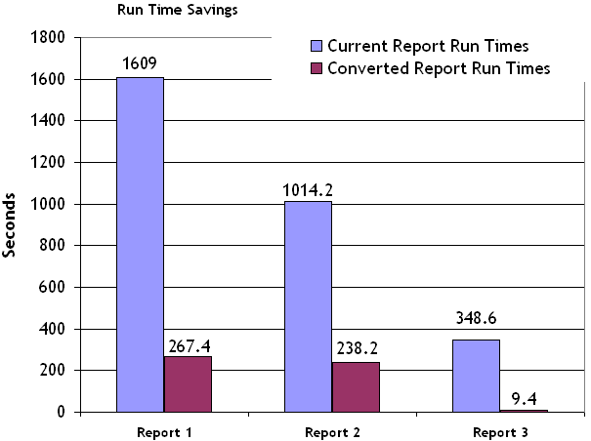
For more information about this project, contact Green Belt Korki Whitaker or Project Sponsor Jim Kulwicki.

Additional details about this and other Six Sigma projects can be found on Sharepoint at http://projects.sharepoint.ntl-city.com/SixSigma/default.aspx

In early 2006, National City implemented the Rewards Point program. One production table that was not designed for history nor optimized for reporting provided data for 3 basic reports. The physical size of the table grew rapidly, and the processing time to create reports became unacceptable.

Production processing was negatively impacted by reports using production data, rather than a separate reporting database.

- By Korki Whitaker, Business Intelligence Reporting Team / Common Services
Project Spotlight:
Reward Points –Optimize Reporting Tables

